**Comparator Interface**

A comparator interface is used to order the objects of user-defined classes. A comparator object is capable of comparing two objects of the same class**.** Following function compare obj1 with obj2.

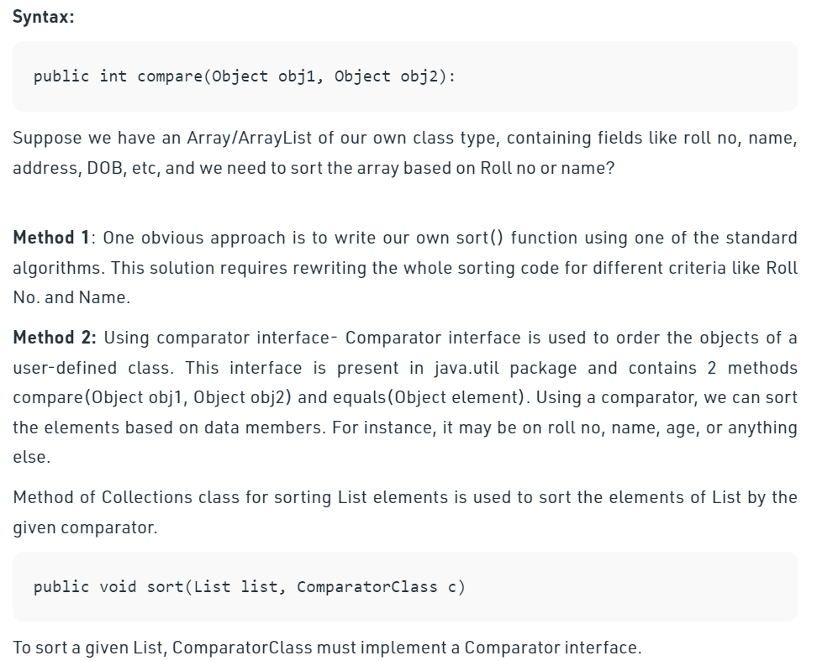

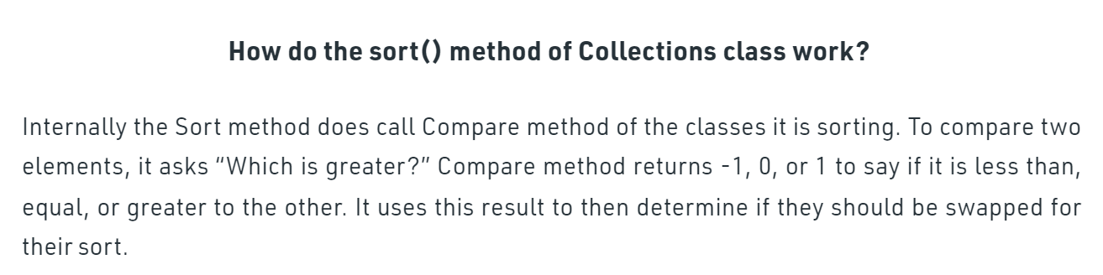

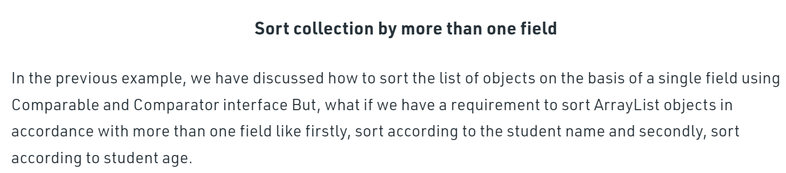

🡺Sorting on the basis of the one field

jj

🡺Sort Collection by more than one field